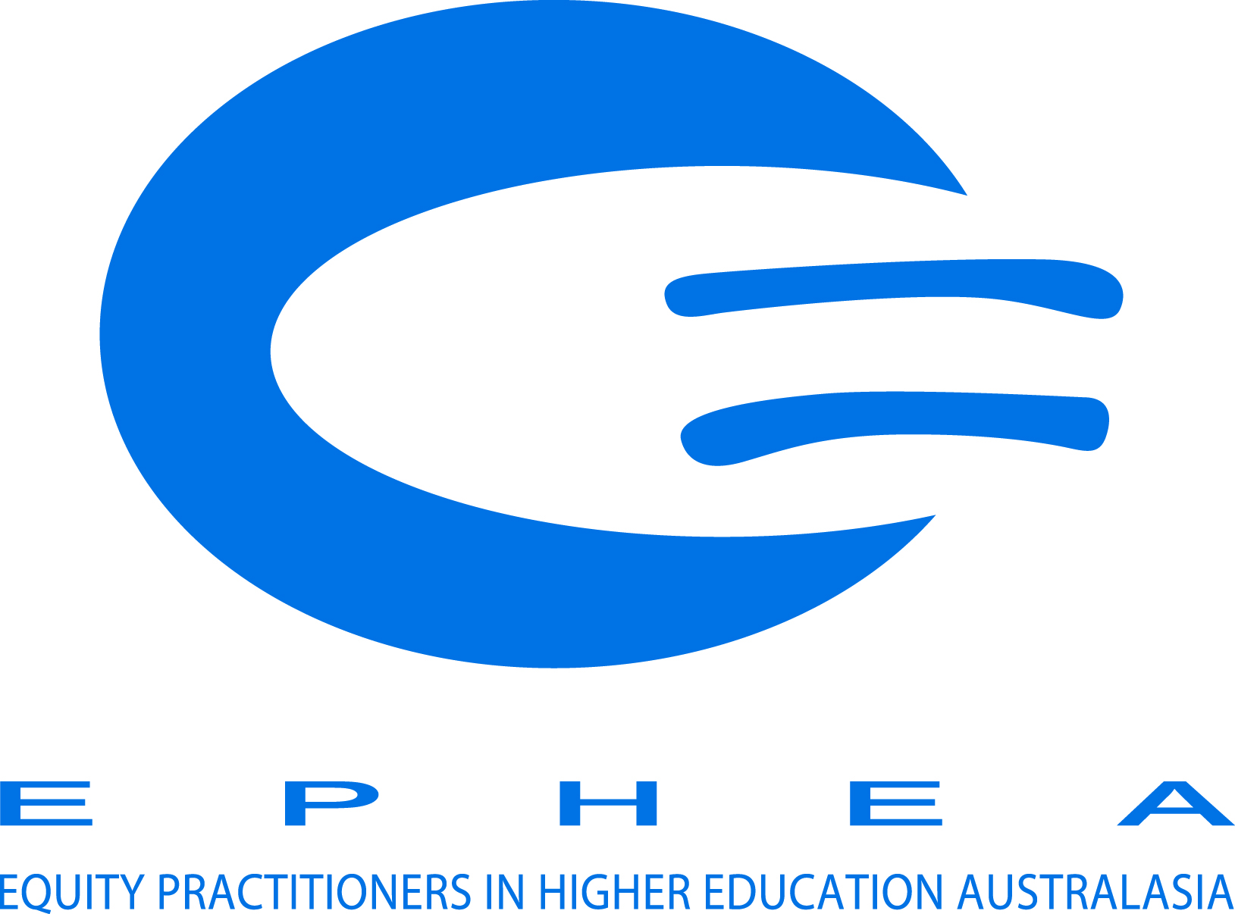

**tHE NEWSLETTER FOR Equity Practitioners in Higher Education Australasia**

# From the Committee

Happy New Year to all our members!

Your EPHEA committee is:

Gabrielle O’Brien (GU)

President

Dee Gibbon (UQ)  
Vice-President

Ruth Tregale (Macquarie)

Treasurer

Lara Rafferty (RMIT)

Secretary

Joanna Leonard (UTS)  
Membership Officer

Keane Wheeler (USC)

Indigenous Rep & Ordinary Member

Juliet Nanai (AUT, NZ)

Ordinary Member

Louise Pollard (UWA)

Ordinary Member

Kate Flynn (QUT)  
Ordinary Member

Cathie Walsh (UoA, NZ)  
NZ Rep & Ordinary Member

**EPHEA Executive committee**

2017 is already showing itself to be setting a frantic pace for the EPHEA Executive Committee so much so that this is February’s newsletter going out in May – so double the news. No doubt everyone is experiencing a similar pace in their own sphere of activity. The EPHEA Executive started the year by having a one day strategic planning meeting to review progress to date and continue to work towards the goals set out in the 2015 – 2017 strategic plan – more information about this below.

After the 2016 AGM we have some new members but we very much want to thank our resigning members: Lisa O’Neill – Vice President; Arif Ongu – Membership Officer and Terry O’Neill – NZ Representative and Ordinary member. Without their contribution we couldn’t manage the various activities the Executive oversees.

We do have some fabulous new members: Dee Gibbon – Vice President who is the Associate Director, Workplace Diversity and Inclusion at UQ; Kate Flynn, Ordinary Member who is Senior Equity Officer, Widening Participate at QUT; Cathie Walsh, Ordinary Member and NZ Rep who is Director, Staff Equity at University of Auckland; and Joanna Leonard, Memberships Officer, who is Equity and Diversity Officer at UTS.

We have a great team leading the way in 2017 and we hope we can continue to provide strong leadership and vision for equity practitioners in this space. This year is also the 30th anniversary of EPHEA Conference – so November also promises to be a great time to celebrate what will be a big year and a significant commemoration. **The EPHEA Conference website will be open mid-May!**

Regards

Gabrielle O’Brien, President  
**On behalf of the EPHEA Executive Committee**

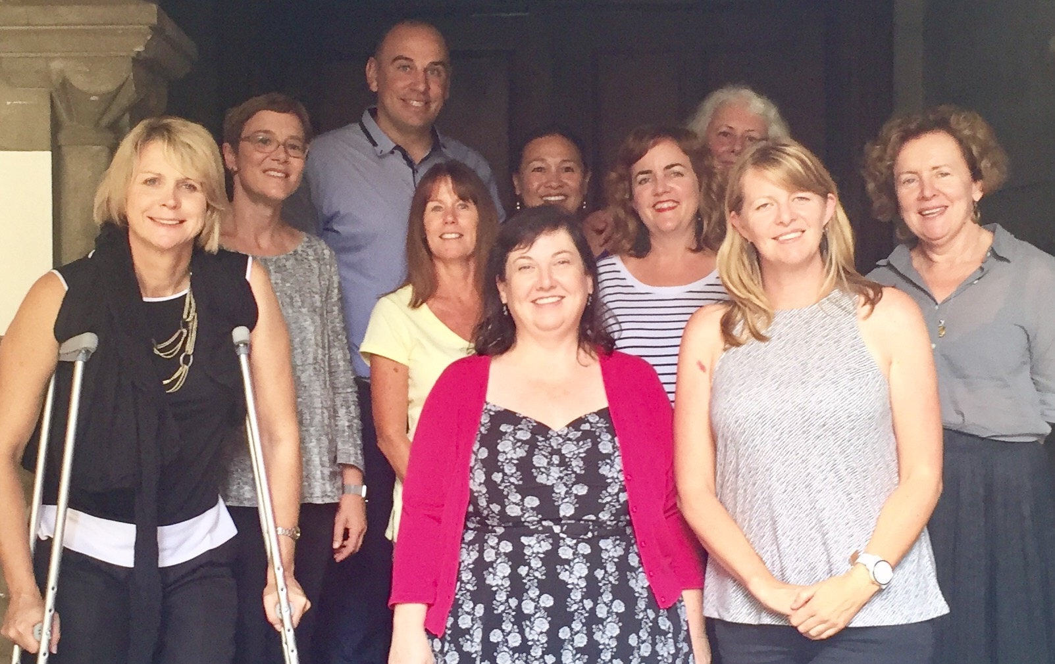

# STRATEGIC PLANNING

The EPHEA Executive met on 10th February for a strategic planning day to discuss the year ahead and the direction of the organisation. Key focus was on the strategic plan which was based on feedback from members at the 2015 EPHEA Conference.

Key strategic objectives of the plan include:

* **Strategic Objective 1:** Reputation and profile – build and consolidate EPHEA’s reputation and profile in the Higher Education sector as Australasia’s leading professional organization of equity practitioners in tertiary education for both staff and students.
* **Strategic Objective 2:** Supporting members: providing a collegial network for sharing knowledge, research and practice
* **Strategic Objective 3:** Influencing and informing policy: initiating and contributing to discussion and making policy recommendations of equal opportunity and affirmative action issues in higher education to governments and higher education sector agencies
* **Strategic Objective 4:** Strengthening partnerships: create national and international linkages, partnerships and collaborations to support EPHEA’s strategic goals

Progress on these objectives can be found on the EPHEA website at [www.ephea.org](http://www.ephea.org) under ‘governance’. This plan spans 2016 and 2017 and at the 2017 EPHEA Conference a similar process of gathering feedback will be undertaken to ensure that we continue to meet member needs. If you have any feedback please contact us at [info@ephea.org.au](mailto:info@ephea.org.au)

# STAFF EQUITY

## Community of practice for gender equality

We are currently investigating ways of being able to share as a group (including draft documents etc) and can hopefully set this up using sharing platforms that work from everyone with a view to sharing outcomes through the EPHEA Conference in November. If you are not already on the Gender Equity Strategy Group email list and would like to be included, please email [d.gibbon@uq.edu.au](mailto:d.gibbon@uq.edu.au)

# STUDENT EQUITY

## HEPPP and the Budget

Minister Birmingham released the [Higher Education Policy Package](https://docs.education.gov.au/system/files/doc/other/ed17-0138_-_he_-_glossy_budget_report_acc.pdf) on 1 May. By way of quick summary there is good news and bad news – an overview is available on Department of Education [website](https://docs.education.gov.au/node/43531)

* Continued support of the demand drive system but cuts to university funding through efficiency dividends which will see less money in the sector overall and students bearing a greater burden through their fees.
* Reduction in payment thresholds for students repaying HECS-HELP loans from $52k to $42k which will have a particular impact on prospective students from LSES backgrounds
* From 1 January 2018, subsidies for Australian permanent residents and New Zealand (NZ) citizens enrolling in a Commonwealth Supported Place (CSP) will be withdrawn, making them fee-paying students. The Commonwealth will instead support permanent residents and NZ citizens through access to income-contingent loans which means that they will not have to meet the cost of upfront fees. This is a backwards step in creating opportunities for Maori and Pasifika communities and other permanent residents in accessing education
* HEPPP is retained with three-year funding streams for greater stability which will vastly improve the ability to plan programs. Performance funding for LSES and Indigenous students will be part of the package based on success rates which indicates less base grant funding.
* NPP (National Priority Pool) funding is retained with greater focus on rigorous evaluation and improved inter-institutional collaboration.
* Creation of regional education hubs to allow for more student choice in regional areas – there are already two hubs in Geraldton (WA) and Cooma (NSW) with further work being considered for the Pilbara. Further hubs are subject to feasibility studies.
* Additional funding to support enabling and sub-bachelor programs which will hopefully assist students who aren’t quite ready to transition into bachelor programs more smoothly and with better success rates.
* Support for work integrated learning units within programs
* Support for TEQSA and Higher Education Standards Panel
* Teaching awards to be transferred to Universities Australia to administer

As Universities Australia has pointing out in their [media release](https://www.universitiesaustralia.edu.au/Media-and-Events/media-releases/Uni-cuts-aren-t-clever--but-merit-in-new-uni-equity-and-work-placement-measures#.WQlyPxN95tR) it is unfortunate that in some areas the Government has been short-sighted about the value of Higher Education to the economy and instead looking for some short term savings at the expense of future students.

We are still waiting for news of the HEPPP Review outcomes. All reports suggest it is completed but awaiting sign off from the Minister. It would be right to assume that the Review is likely to coincide with the May 9 Budget. This Review and the Budget papers will give a better idea what the new HEPPP funding looks like especially with regards to allocations and performance requirements.

The EPHEA Executive has a meeting with the new Manager of the Governance, Quality and Access Branch in the Higher Education Group within the Australian Government Department of Education and Training.

**We will also be responding to the reform package and copying in relevant ministers to ensure they understand the implications for students from equity groups when deciding which way to vote. If you would like to contribute to this response please email us** [**info@ephea.org**](mailto:info@ephea.org)

## NCSEHE update

Representation at NCSEHE

Louise Pollard has stepped down from representing EPHEA on the [NCSEHE Advisory Board](https://www.ncsehe.edu.au/about/advisory-board/) and this will be now taken up by EPHEA President, Gabrielle O’Brien. Ruth Tregale will continue on the [NCSEHE Advisory Committee](https://www.ncsehe.edu.au/about/advisory-committee/). Both these positions allow us to have a voice for practitioners in this space and we are very grateful for the support of the NCSEHE.

NCSEHE Forum

On Monday 28 November 2016, the NCSEHE hosted the [*Facilitating an Innovative Future through Equity 2016 National Research Forum*](https://www.ncsehe.edu.au/facilitating-innovative-future-equity-fifte16/) at the National Press Club in Canberra. The Forum was an exciting opportunity for equity policy makers, researchers and practitioners to come together, share ideas and contribute to shaping the future of equity in Australian higher education. The NCSEHE was kind enough to invite members of the EPHEA Executive to the forum and we reported to members via the listerv outcomes from this forum.

The highlight of the program was presentations from the NCSEHE Equity Fellows Programme by Dr Nadine Zacharias on [The Australian Student Equity Program and Institutional Change](https://www.ncsehe.edu.au/australian-student-equity-program-institutional-change/); Dr Erica Southgate on [Fair Connection to Professional Careers](https://www.ncsehe.edu.au/fair-connection-professional-careers/); and Dr Cathy Stone on [Opportunity through online learning](https://www.ncsehe.edu.au/opportunity-online-learning/). The Ten Conversations were also an opportunity to explore some significant issues facing the sector and further reading on this is available online.

New NCSEHE Fellows

The Federal Minister for Education and Training, the Hon. Simon Birmingham, then took the stage to congratulate the sector for its work in improving rates of higher education enrolment by students from disadvantaged backgrounds; share his background as the first in his family to attend university; and announce [the NCSEHE’s three 2017 Equity Fellows](https://www.ncsehe.edu.au/2017-equity-fellows/): Associate Professor James Smith; Matt Brett and our very own EPHEA Executive member Louise Pollard. We are working closer with the NCSEHE and these Equity Fellows to support their work – as we have done with the previous fellows and look forward to hearing the outcomes from their research at the 2017 EPHEA Conference.

New NCSEHE publications

* A new series of online reports will be launched in May, informing policy and practice by collating NCSEHE funded research to offer a series of evidence based resources. The first in this series will focus on successful outcomes for students with disability in higher education and will be available to all NCSEHE subscribers. Subscribe at the [NCSEHE website](mailto:NCSEHE%20website%20) or email [ncsehe@curtin.edu.au](mailto:ncsehe@curtin.edu.au)to receive this downloadable resource.
* Five years on from the introduction of The Higher Education Participation and Partnerships Program (HEPPP), NCSEHE is compiling a case study publication to highlight the many successful initiatives supported by the program. Five years on from HEPPP will be released late in 2017 in digital and print, and made available on the NCSEHE website. In the lead up to the publication, the NCSEHE will be featuring a new series: ‘[My Story: Student Voice](https://www.ncsehe.edu.au/category/my-story/)’, celebrating the individual successes behind HEPPP funded programs. If you have not been contacted about this and requested to provide your case study please email us at [NCSEHE@curtin.edu.au](mailto:NCSEHE@curtin.edu.au)

NCSEHE Events

* 2017 Visiting Fellows Associate Professor Sarah O’Shea, University of Wollongong and NCSEHE Research Fellow Dr Cathy Stone will be at the NCSEHE from 22 to 26 May 2017. They will conduct a session for staff combining their expertise in using online education to assist First-In-Family students in completing their tertiary studies and moving into full careers.
* The NCSEHE will release the third annual Informing Policy and Practice publication in July 2017. Featuring 13 reports from the 2016 Research Grants Program and the 2016 Equity Fellows Program, accompanied by expert commentary, Informing Policy and Practice III will be available in print and digital formats and will be presented at the 2017 STARS Conference.

Subscribe at the [NCSEHE website](mailto:NCSEHE%20website%20) or email [ncsehe@curtin.edu.au](mailto:ncsehe@curtin.edu.au) for more information.

## Commonwealth Indigenous scholarships

As you know the source funding for the Commonwealth Scholarships Programme supporting Aboriginal and Torres Strait Islander students and a number of other programs such as tutorial assistance were combined into the [Indigenous Student Success Programme](https://www.dpmc.gov.au/news-centre/indigenous-affairs/2016-17-budget-indigenous-student-success-higher-education) (ISSP) for 2017.

The ISSP sits within the Indigenous Advancement Strategy (IAS) governed by the Department of the Prime Minister and Cabinet. Last year the Australian National Audit Office reviewed the IAS and the results are now available [here](https://www.anao.gov.au/work/performance-audit/indigenous-advancement-strategy).

The media have been [critical](http://www.abc.net.au/news/2017-02-04/analysis-how-not-to-spend-$5-billion-in-taxpayers-dollars/8240968) about the scheme and no doubt as practitioners your experience working with a contracted budget for scholarships and tutorial assistance reflects some of the issues raised in the report. We are happy to make specific recommendations to the Department of the Premier and Cabinet as appropriate to ensure continued access to targeted financial and educational support for this cohort.

# New Zealand and the Pacific

## NZ and Pacific representation

Currently, EPHEA has two NZ representatives on the EPHEA Committee – Cathie Walsh and Juliet Nanai. Please make contact with Cathie and Juliet if you would like to highlight any particular issues.

|  |  |
| --- | --- |
| Cathie Walsh, Ordinary member and NZ representative  University of Auckland, NZ  [cathie.walsh@auckland.ac.nz](mailto:cathie.walsh@auckland.ac.nz) | Juliet Nanai, Ordinary member  AUT University, Auckland  [juliet.nanai@aut.ac.nz](mailto:juliet.nanai@aut.ac.nz) |

Current activity undertaken by the NZ Chapter is outlined in Chapter reports below.

# Other activities

## Respect. Now. Always. national university student survey

In late 2016, tens of thousands of Australian university students were asked to participate in Australia’s first-ever national prevalence survey on university student experiences of sexual assault and sexual harassment.

The survey results will give Australian universities a clearer evidence base to guide further work to prevent and address sexual assault and sexual harassment. It is a critical part of the university sector’s Respect. Now. Always. campaign that aims to  keep university students safe.

The leaders of all 39 Australian universities asked the Australian Human Rights Commission to investigate the nature and scale of these behaviours. The survey is supported by the National Union of Students and the National Tertiary Education Union.

All survey responses are confidential and the privacy of everyone invited to take part is protected. No university will ever know whether a student has participated in the survey or what they say.

**The survey findings will be published by the Commission on August 1, 2017. Find out more** [**here**](https://www.universitiesaustralia.edu.au/Media-and-Events/media-releases/Groundbreaking-national-university-student-survey-on-sexual-assault-and-sexual-harassment-launched-today#.V8OySPl96Wg)

# Membership

Currently, 26 Australian Higher Education Institutions, 3 New Zealand Universities, the Council of Postgraduate Associations and the NCSEHE have institutional membership with EPHEA. Additionally, we have individual members at two further Australian universities

If you have not yet paid your membership fees for 2017, there is still time, and we ask for your continued support so that we can implement the activities contained in our Strategic Plan. Our memberships officer will be writing to paid members to confirm staff who should be included on the institutional members as well as writing to those universities who aren’t members or who haven’t paid.

EPHEA membership provides a range of benefits including discounted rates for the EPHEA conference.

# Local chapter activities

## Chapter grant funding

Just a reminder to Chapters who hold development grants to host local networking and knowledge-sharing activities. You need to ensure your funds are utilised appropriately, acquitted by the end of 2016 and you will be asked to report on activities for the year. For Chapters considering activity for next year you find out about Chapter grants [here](http://www.ephea.org/#!convenors/c21ua). We are seeking volunteers for Chapter convenors for ACT, TAS, and NT. [Please contact us for more information](http://www.ephea.org/contact)

Below is information from some of our Chapters on current activity:

## WESTERN AUSTRALIA

The WA EPHEA Chapter continues to strengthen and collaborate. The Chapter has met each quarter since July 2014 and now includes members from every Western Australian university, including the private institution, Notre Dame Australia. Earlier this year, Chapter Convenor, Luke Webster (Curtin University), proposed the Chapter form an organisational committee, including representatives from each of the five universities. The organisational committee will oversee the WA EPHEA mailing list, the scheduling and coordination of meetings and professional development opportunities, the dissemination of Chapter news and events information and liaising with the National Committee. The 2016 WA EPHEA Chapter Organisational Committee members include Claire Watkins (Edith Cowan University), Kerina Puttman (Murdoch), Liz Beal (Notre Dame) and Elisa McGowan (University of Western Australia).

In April, the Chapter utilised the funding grant awarded by EPHEA to host a Professional Development Workshop for members and fellow equity practitioners. The event was hosted by the University of Western Australia. Representatives from all five WA universities were in attendance and had an opportunity to hear from Evyn Webster, a non-profit veteran and seasoned social worker, who discussed the challenges of engaging with the community in an environment of diminishing funding, and the need for equity practitioners to be resilient and consider their raison d’etre. Attendees were also briefed by Allan Blagaich, CEO, School Curriculum and Standards Authority (SCASA) and SCASA Chair, Emeritus Professor Patrick Garnett, on the impending changes to the Western Australian Certificate of Education. The changes, which relate to the addition of an Online Literacy and Numeracy Assessment in an effort to improve secondary school graduation standards, are expected to have an equity impact. Dr Shamim Samani, Curtin University's Ethics, Equity and Social Justice Project Manager, rounded out the afternoon by presenting a session on the evaluation of equity projects.

Where it is possible, and to save on costs, the Chapter partners with like-minded organisations to deliver value to its members. The last quarterly meeting was held in tandem with the NCSEHE’s hosting of three American Council on Education Fellows, Professor Joanne Goodell, Professor Janelle Chiasera and Dr Rosalee Rush. The Fellows each gave a presentation; Joanne discussed the US college system’s move to performance-based funding; Janelle provided the group with a history of higher education in the United States and discussed the increasing need for diversity and equity planning, the result of changing student demographics and racial tensions; and Rosalee rounded out the afternoon by explaining how Bloomsburg University dealt with a natural disaster, ensuring the university did its part to keep students, staff and local community members safe and informed. The NCSEHE has had the ACE Fellows’ presentations transcribed, and the presentations, audio recordings and transcriptions are now available for download from the Centre’s website at [ncsehe.edu.au/american-council-on-education-fellows/](https://www.ncsehe.edu.au/american-council-on-education-fellows/)

The WA Chapter also met in June, for an information session about the ‘What’s Uni Like?’ MOOC hosted by Josu Abrego-Sanz from Charles Sturt University. The next quarterly meeting will be held on 31 August at ECU following a NCSEHE professional development workshop with NCSEHE Equity Fellowship Dr Nadine Zacharias from Deakin University, who will be conducting state-based sessions on student equity policy and practice, building on the Special Interest Group she presented at the 2016 STARS conference.

## NEW ZEALAND CHAPTER

The NZ EPHEA Chapter is most appreciative of the EPHEA grant of $1000 to assist chapter development. This was used for very successful national EPHEA symposium held in Auckland on 4th July 2016.

Eighty-five participants registered from eight New Zealand tertiary institutions. Evaluations of the symposium were overwhelmingly positive. Participants were appreciative of the opportunity to meet, network and share knowledge on a range of equity topics and learn about EPHEA. There are plans to hold another symposium next year.

NZ Equal Pay Amendment Bill

This bill amends the Equal Pay Act 1972 and the Employment Relations Act 2000 and is currently at its first reading before parliament. Its intention is to remove discrimination in pay rates between men and women in the same jobs by making publicly available statistical information relating to their rates of remuneration. Other employees could then access that information, to compare their wage with that of others doing the same job.

PG Course addressing transgender health

The University of Auckland is planning a new postgraduate course in the specialisation of youth health which would address the clinical health care of young transgender people, covering medical, psychological, social and legal aspects of care. This is due to a rapid increase in the numbers of transgender young people coming forward for health services and clinicians asking for help and further training in this area. Given the quite negative mental and health outcomes for young transgender people the Equity Office is extremely pleased in this development.

Third gender identification

Provision of a third gender choice, “Gender Diverse”, will be available for staff on the upcoming University of Auckland Staff Survey. Hopefully all data collections for staff and students will follow suit.

Diversity forum at AUT

In March, Auckland University of Technology provided a diversity forum for members of AUT’s burgeoning diverse staff to engage in developing a programme of work to enhance the university’s effectiveness and understanding in the crucial areas of advancing diversity and inclusiveness. 166 staff registered and there were 40+ presenters through panels, teams and individually. The newly appointed University Director of Diversity Edwina Pio worked closely with Dr Andrea Vujnovich AVC Corporate in establishing this forum.

The Institute for Courageous Conversations about Race

Unitec has created a new space for ‘Courageous Conversation’ about race with its launch of the [Institute for Courageous Conversations about Race](http://www.unitec.ac.nz/about-us/unitec-creates-space-for-courageous-conversation-about-race) at Unitec, iCCAR. Unitec signed an agreement to deliver US author and racial equity educator Glenn E. Singleton’s Courageous Conversations about Race protocol throughout the South Pacific. The new initiative helps students, teachers, companies and organisations better understand and harness racial diversity.

“We all need to have courageous conversations about race if we’re really going to understand the problem of racial inequity. This means acknowledging and accepting the differences among us, including race, which can sometimes be an uncomfortable experience. The bottom line is, if you can’t differentiate your students or customers, how can you understand their unique talents and needs?” says Dr Matthew Farry, Director iCCAR

In September, Unitec won the Cultural Celebration category in the 2016 national Diversity Works Awards and in the same month Dr Rick Ede, CE, won the International Racial Equity Leadership Award at National Summit for Courageous Conversation, Austin Texas. **See** **Attachment 1** **for more in the ICCAR**

# Contact

If you would like further information or would like to contribute please contact us via the [EPHEA website’s contact page](http://www.ephea.org/#!contact/co59).

# Attachment 1

